Foundation 1:
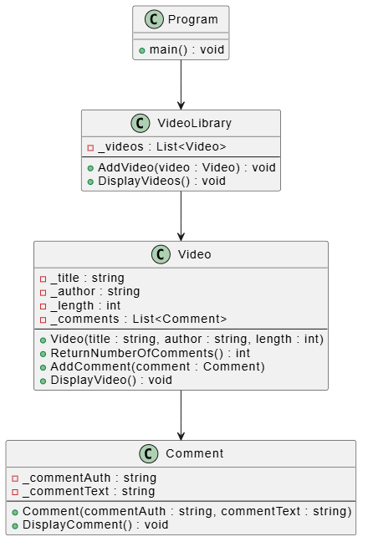
Program takes from VideoLibrary. VideoLibrary has a list of Video that it can display on command. Video has a list of Comment that it can list blow the video it displays. In other words, VideosLibrary has a list of Video that has a list of Comment.

Scroll down for Foundation 2
Foundation 2:
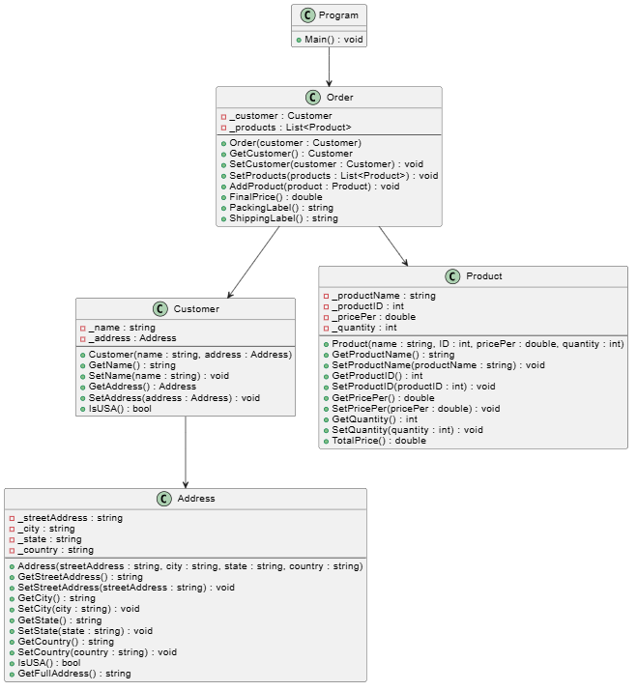
Program creates and uses Order, which has a Customer object inside of it. Order also has a list of products. The Customer object will have an Address object within it.

Scroll down for Foundation 3
Foundation 3:
Program creates Events. Lecture, Reception, and OutdoorGather all inherit from Event. Each Event holds an Address.
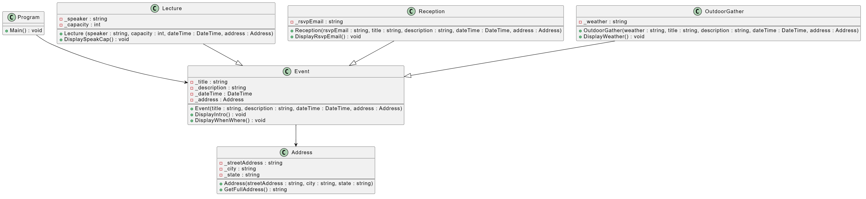
Scroll down for Foundation 4

Foundation 4:
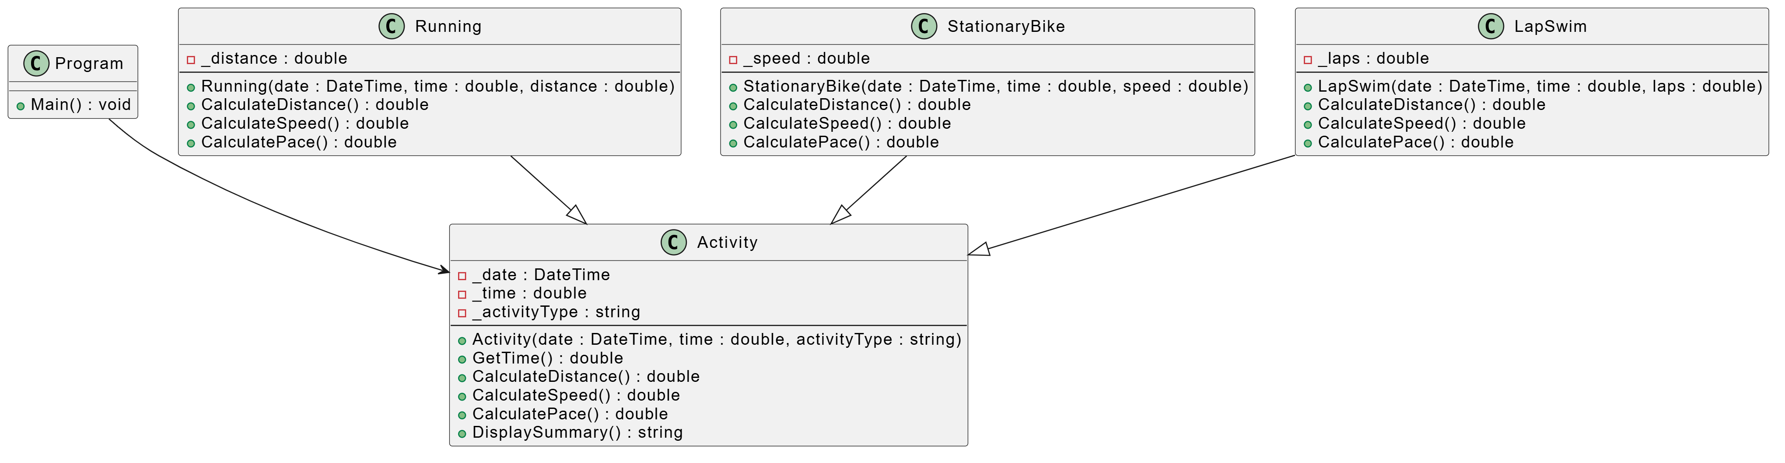
Program creates Activities. Running, StationaryBike, and LapSwim all inherit from Activity. Each subclass overrides the base class methods to calculate distance, speed, and pace in their own way.

